Flowchart 2, Week 2, Lab 2
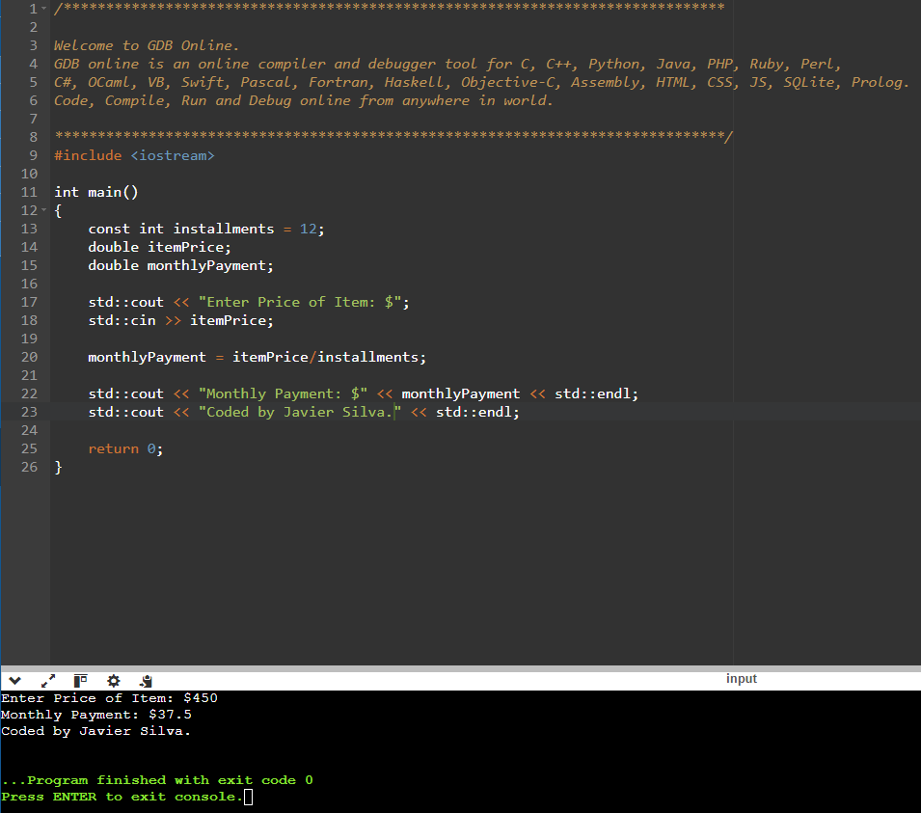

Flowchart 2, Week 2, Lab 3
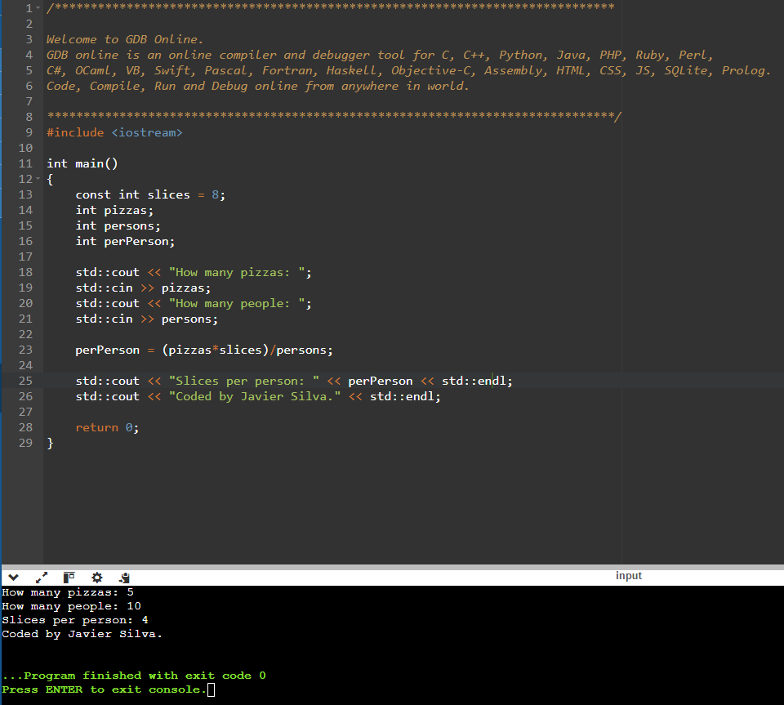

Flowchart 2, Week 2, Lab 4
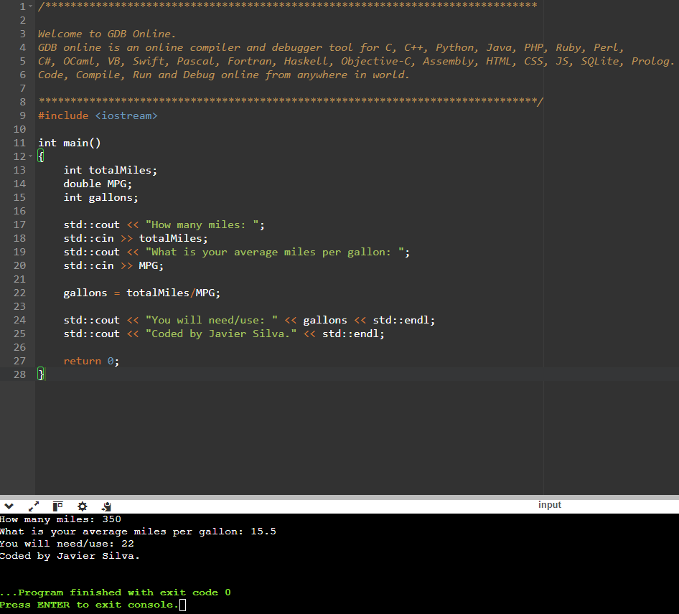

Flowchart 2, Week 2, Lab 8
